Teresalina Paez

Mrigank Tiwari

Visualization of Complex Data

03 May, 2017

**What is happening with the gender inequality in the last ten years?**

1. **Introduction**

The world of today presents important advances in problems of health, technology, education, and many other aspects. However, since the beginning of civilizations there have been social differences between men and women. These differences based on the sex are not based on intrinsic limitations. In this study we want to evaluate if in the last 10 years the world can show some progress. For these purposes we will be evaluating the gender inequality from 4 perspectives: Educational Attainment, Economic Participation, Health and Political Empowerment. For all these perspective we will be evaluating different indicators to get an idea about what is happening in this aspects.Also, as we evaluate these indicators we want to give an idea about the magnitude of the inequality in these aspects. Based on these indicators we want to make conclusions about what is on progress, stagnation and arrears in terms of gender inequality.

**2. Description of the data set**

To perform this study it was necessary to combine not only different indicators but countries and years. At the beginning of our work we knew that this aspect would be challenging, however as we were studying our subject we understood the difficulty. For our help there are international organization that publicly publish the data they compile for their studies. They also carry out the task of standardizing the indicators so that they can be compared between countries. In that sense, we evaluated different databases, and selected the database offered by the world bank, specifically for the evaluation of gender differences. The original data source is described as follows:

Type: Time series

Periodicity: Annual

Last Updated: 17-Apr-2017

Economy Coverage: WLD, EAP, ECA, LAC, MNA, SAS, SSA, HIC, LMY, IBRD, IDA

Granularity: National, Regional

Number of Economies: 217

Topic: Gender

Indicators : 695

Update Frequency: Quarterly

Update Schedule: April, July, September, December

Contact Details: data@worldbank.org

Access Options: API, Bulk download, Query tool

Attribution/citation: Gender Statistics, The World Bank

Coverage: 1960 - 2016

The actual dataset is much broader than the one required in this study, therefore our next step was to select the indicators we considered more relevant for the 4 dimensions selected to be studied. In that sense the following indicators were selected:

**Educational attainment (12)**

Literacy rate:

Literacy rate, adult female (% of females ages 15 and above)

Literacy rate, adult male (% of males ages 15 and above)

Literacy rate, adult total (% of people ages 15 and above)

School enrollment by stage:

School enrollment, primary (% net)

School enrollment, primary, female (% net)

School enrollment, primary, male (% net)

School enrollment, secondary (% net)

School enrollment, secondary, female (% net)

School enrollment, secondary, male (% net)

School enrollment, tertiary (% gross)

School enrollment, tertiary, female (% gross)

School enrollment, tertiary, male (% gross)

**Economic Participation (9)**

Labor Force:

Labor force participation rate for ages 15-24, female (%) (modeled ILO estimate)

Labor force participation rate for ages 15-24, male (%) (modeled ILO estimate)

Labor force participation rate for ages 15-24, total (%) (modeled ILO estimate)

Unemployment:

Unemployment, female (% of female labor force) (modeled ILO estimate)

Unemployment, male (% of male labor force) (modeled ILO estimate)

Unemployment, total (% of total labor force) (modeled ILO estimate)

Wage and salaried:

Wage and salaried workers, female (% of female employment)

Wage and salaried workers, male (% of male employment)

Wage and salaried workers, total (% of total employment)

**Health (3)**

Life Expectancy

Life expectancy at birth, female (years)

Life expectancy at birth, male (years)

Life expectancy at birth, total (years)

**Political Empowerment (1)**

Proportion of seats held by women in national parliaments (%)

Once we had these indicators for all the countries and therefore regions, the next roadblock was incomplete data. In this type of information it is very common to face these types of inconveniences mainly because the countries do not always have similar mechanisms of collection, storage or sending information in a timely manner. After evaluating methodologies such as interpolation, use of econometric models, a combination of different sources of information, we concluded that we would work with the original incomplete data for several reasons mentioned below:

* Interpolation or Econometric Models: Although there are different methodologies, it requires assuming a type of trend that does not always come close to reality, and since our analysis is precisely the evaluation of the trends of the different indicators, we understood that if we assume any tendency we would affect our conclusions.

* Combination of other data sources: When doing this process it is very important to evaluate if both mechanisms actually used the same methodology for the calculation of the indicator. On the part of our main source we counted on the detailed description of each indicator, however not all sources of information publish this level of detail. Therefore, we did not want to risk comparing or performing calculations that could detract from the analysis.

In fact in extreme cases with very little or no information in some countries, in these assumptions assumed would significantly affect the results. Another aspect taken into account was the type of analysis that we will be performing. To answer our question we understood an exploratory analysis of these indicators, and although the optimum is to have the complete information, we would try to reach our goal as close as possible to reality.

Finally the dataset used had the country,country code, year, and our 33 indicators. In addition, we combine this dataset we other data in order to have the population.

**3. Description of the visualization and analysis**

To fulfill our objective we had to transform the original data into the format in the interpretive tableau automatically and efficiently. In that sense we selected R to perform this preprocessing, that more than preprocessing was simply changing the way it was initially organized. After having the data in the required format, we could follow the following analysis structure for each indicator in the different dimensions:

1. Evaluate the overall trend of the indicator, Specifically this graph will allow us to see if this indicator has generally improved, and to see if there is any particular pattern between men and women.

2. Calculate the difference in the proportions between men and women, which would allow us to calculate the gap in percentage terms. In that sense we can have an idea of ​​the magnitude of the difference and also see the trend.

3. View the global positioning of the countries and determine which are best and worst positioned (2015). Evaluate if there is any regional pattern of improvement.

4. Finally, we will evaluate if any particular country made major changes in the last 10 years.

We will do all these visualizations but just present the ones that are more relevant. Also, we think that Among all the tools used in this class, tableau will help us to show great results.

**4. Describe how you are going to use the data to solve the problem**

The aim of our analysis is to extract some idea of what is happening with the gender inequality in the last ten years?. Gender inequality must be measured from several approaches or points of view. Basically because, the differences between the sexes can be observed in education, economics, health and political empowerment.Taking indicators in only one of these perspectives would only allow limited conclusions on gender inequality. For each perspective we chose at least one indicator that we understood relevant. With the data that we have previously described, we can see the trend that has followed each of the indicators, not only globally, but also by regions and countries. With this data it will also be possible to evaluate not only the current status but also to see what has happened in each indicator in the last 10 years. Although, we have crucial limitations because of the data we are using, we assume that the conclusions will be as close to the reality as the data allow.

**5. Results**

In this study we assume that the optimal point of the indicators is close to zero, that is to say that there are no differences in favor of the men nor in favor of the women. In the majority of studies consulted we could see that researchers commonly refer to the differences that show women behind, although although in several of the indicators we see that there is a greater lag in those indicators that are in favor of men , In cases where women are favored, they must also be treated and presented as gaps of inequality. Then the results are presented in each of the perspectives.

**5.1 Educational Attainment**

From this perspective, we evaluate the gender difference that exists sex. The first indicator related with the Educational Attainment was literacy rate, in this indicator for most countries it is covering the population ages 15 and older, but some include younger ages or are confined to age ranges that tend to inflate literacy rates. This indicator shows the proportion of the population who have passed through the primary education system and acquired basic literacy and numeracy skills. Generally, literacy also encompasses numeracy, the ability to make simple arithmetic calculations.

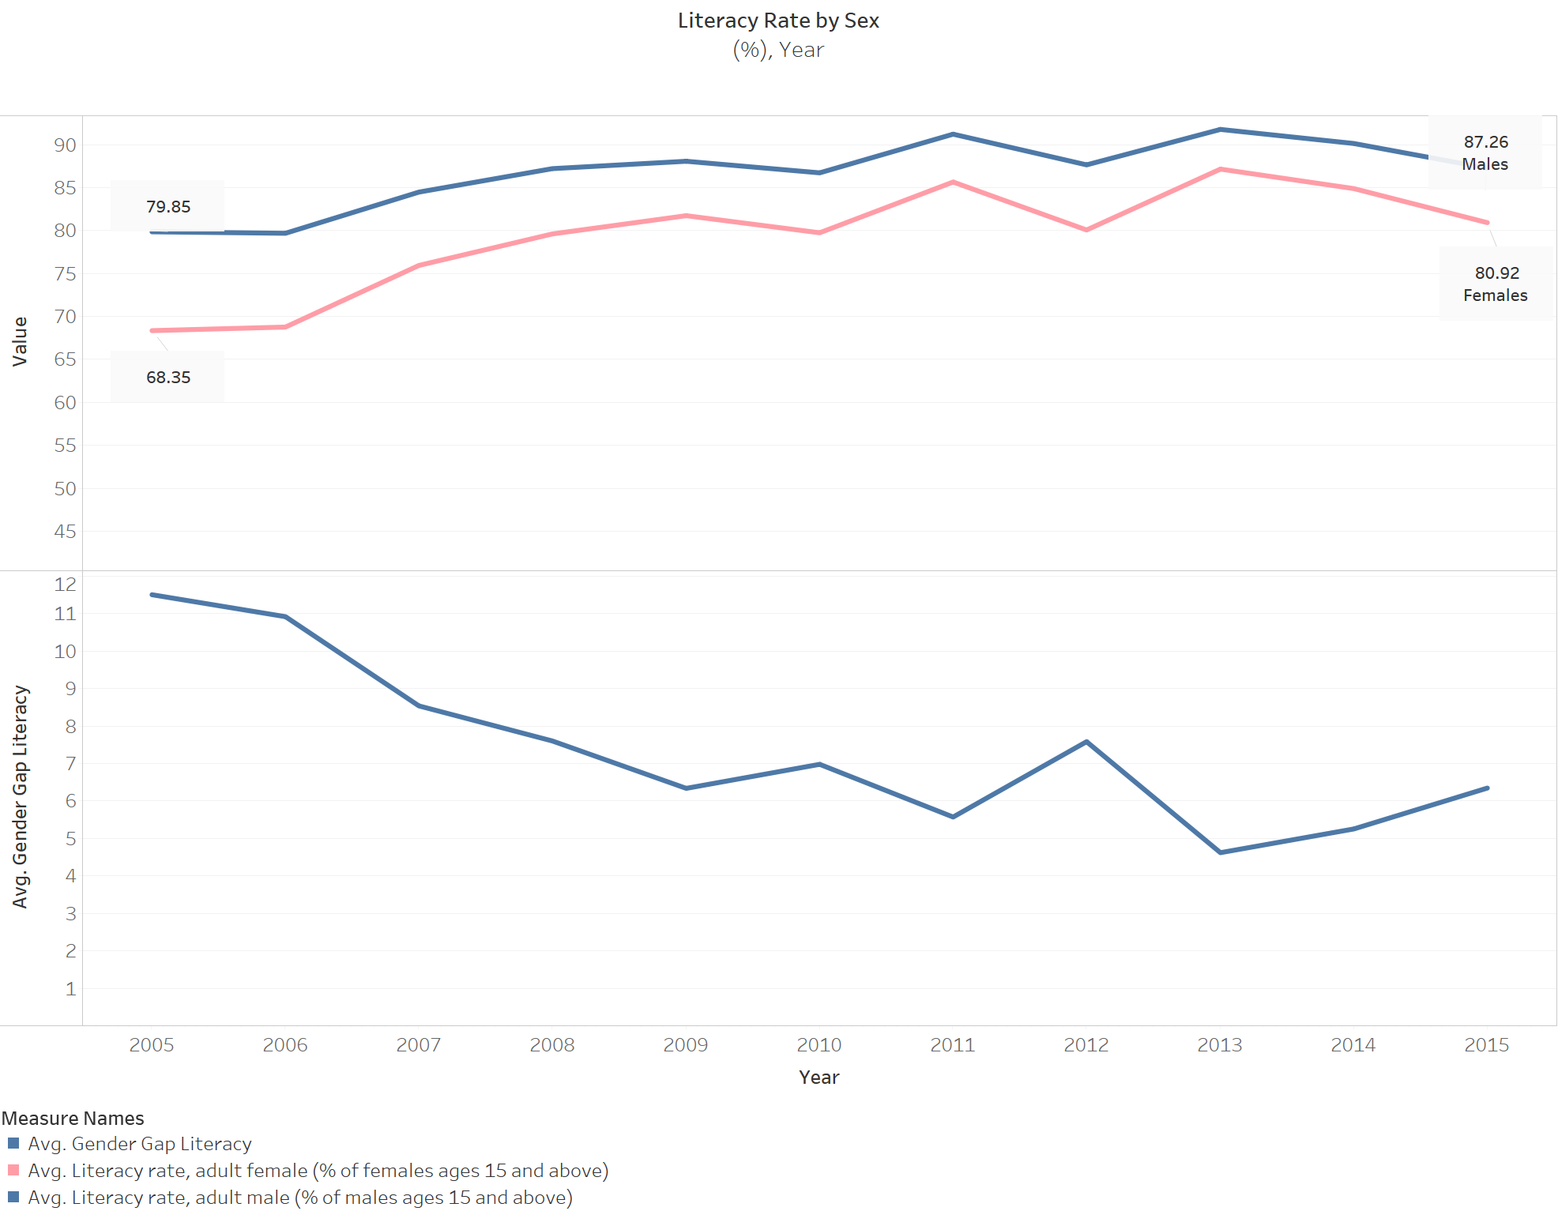

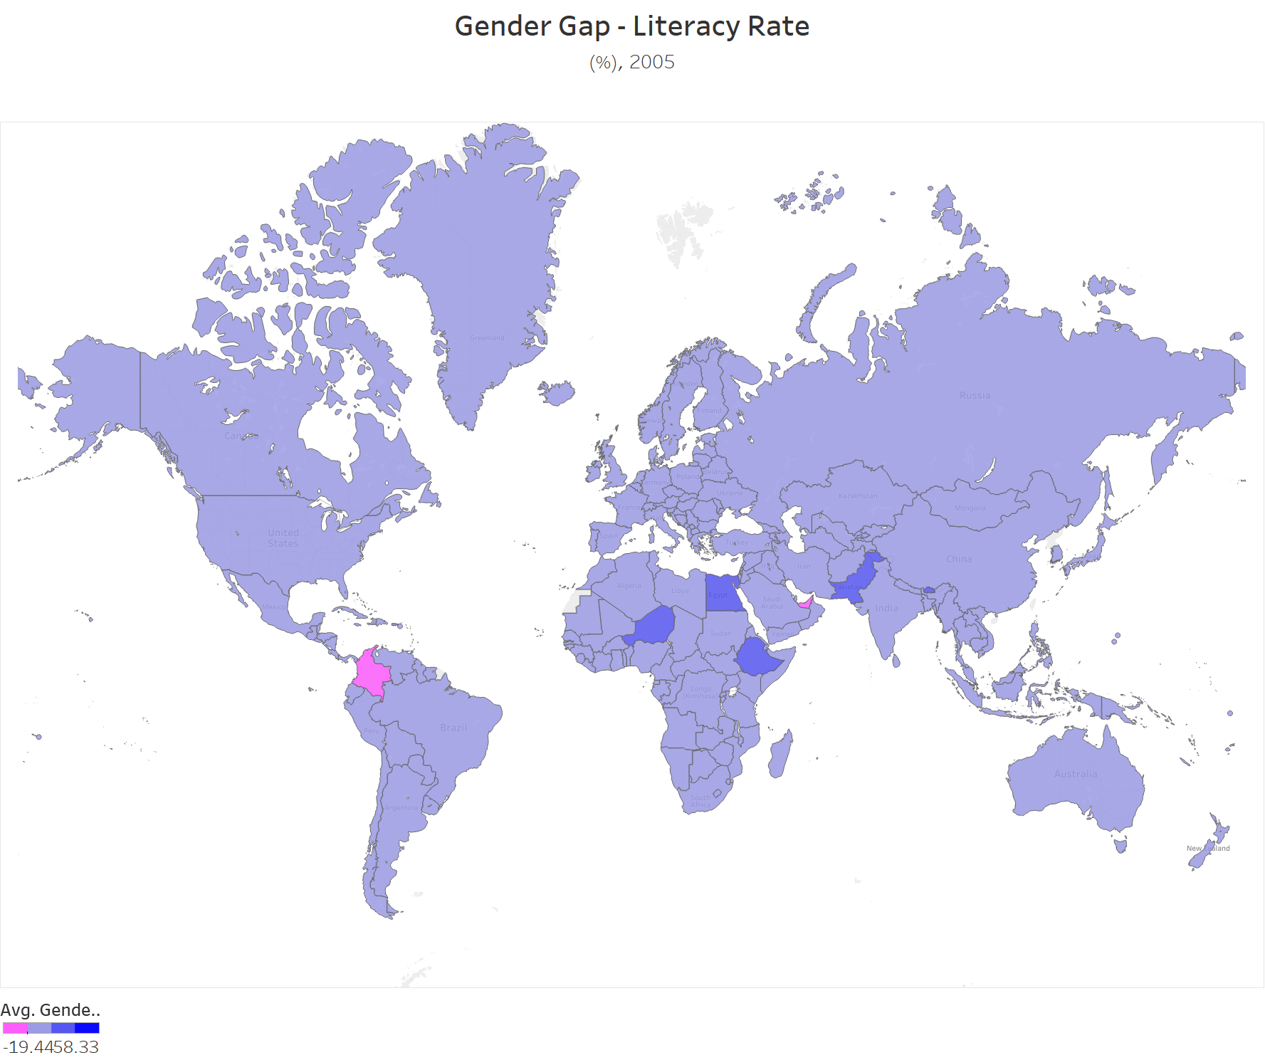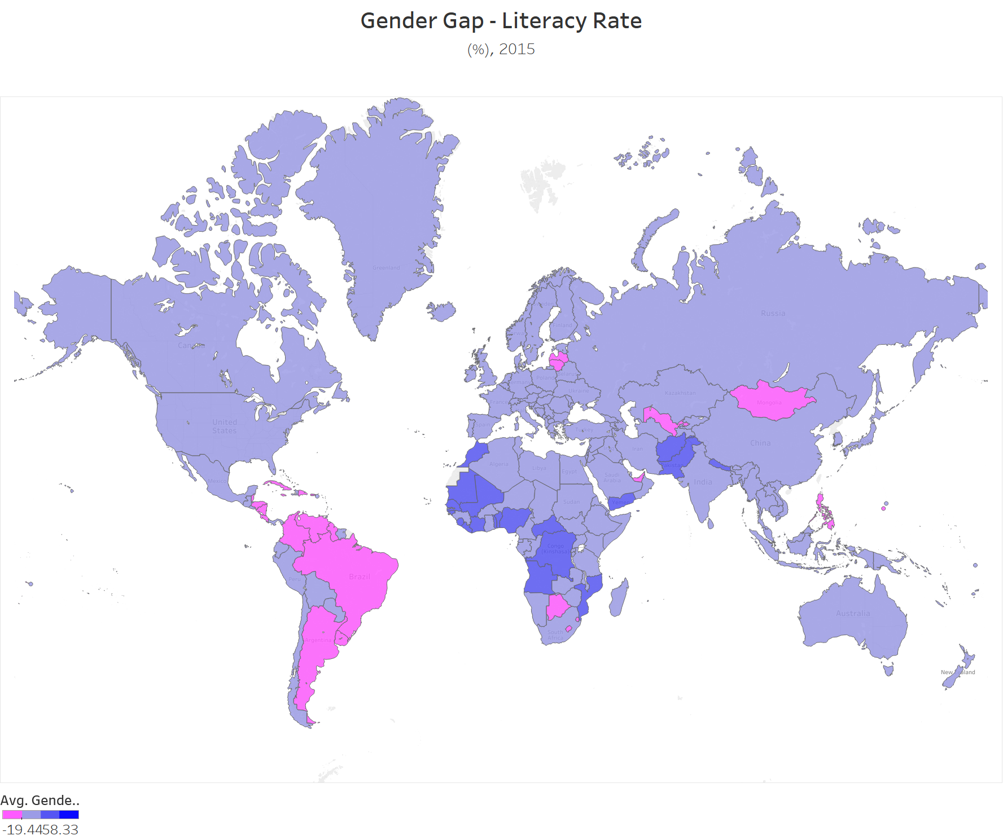

The third map above shows the the countries highlighted in light blue have high male literacy rates than women whereas the ones with dark blue have significantly higher literacy rates for men. The ones with the pink show that the literacy rate of women higher than men. So to generalise we can say that the countries with higher literacy rate with men does go down over the period of 10 years.

The other indicator we used to analyze education attainment was primary, secondary and tertiary school attainment. This attribute is measured as % of people(either male or female) of official age to enroll have enrolled out of total population at official age. The plot from this attribute shows that the education of boys and girls start at similar trend, i.e. there is negligible difference in % of boys and girls enrolled for primary education. As we move towards the higher studies, the gap between the male and female percentages widens and showing a surprising trend. It shows that for secondary and tertiary education, the enrollment percentages are higher for females in comparison to males. For tertiary education enrollment the gap further widens. Basically, this tells us that females are more interested on getting more educated than males. At least in this indicator, if we had found a difference in primary education then we would be more concentrated in this indicator.

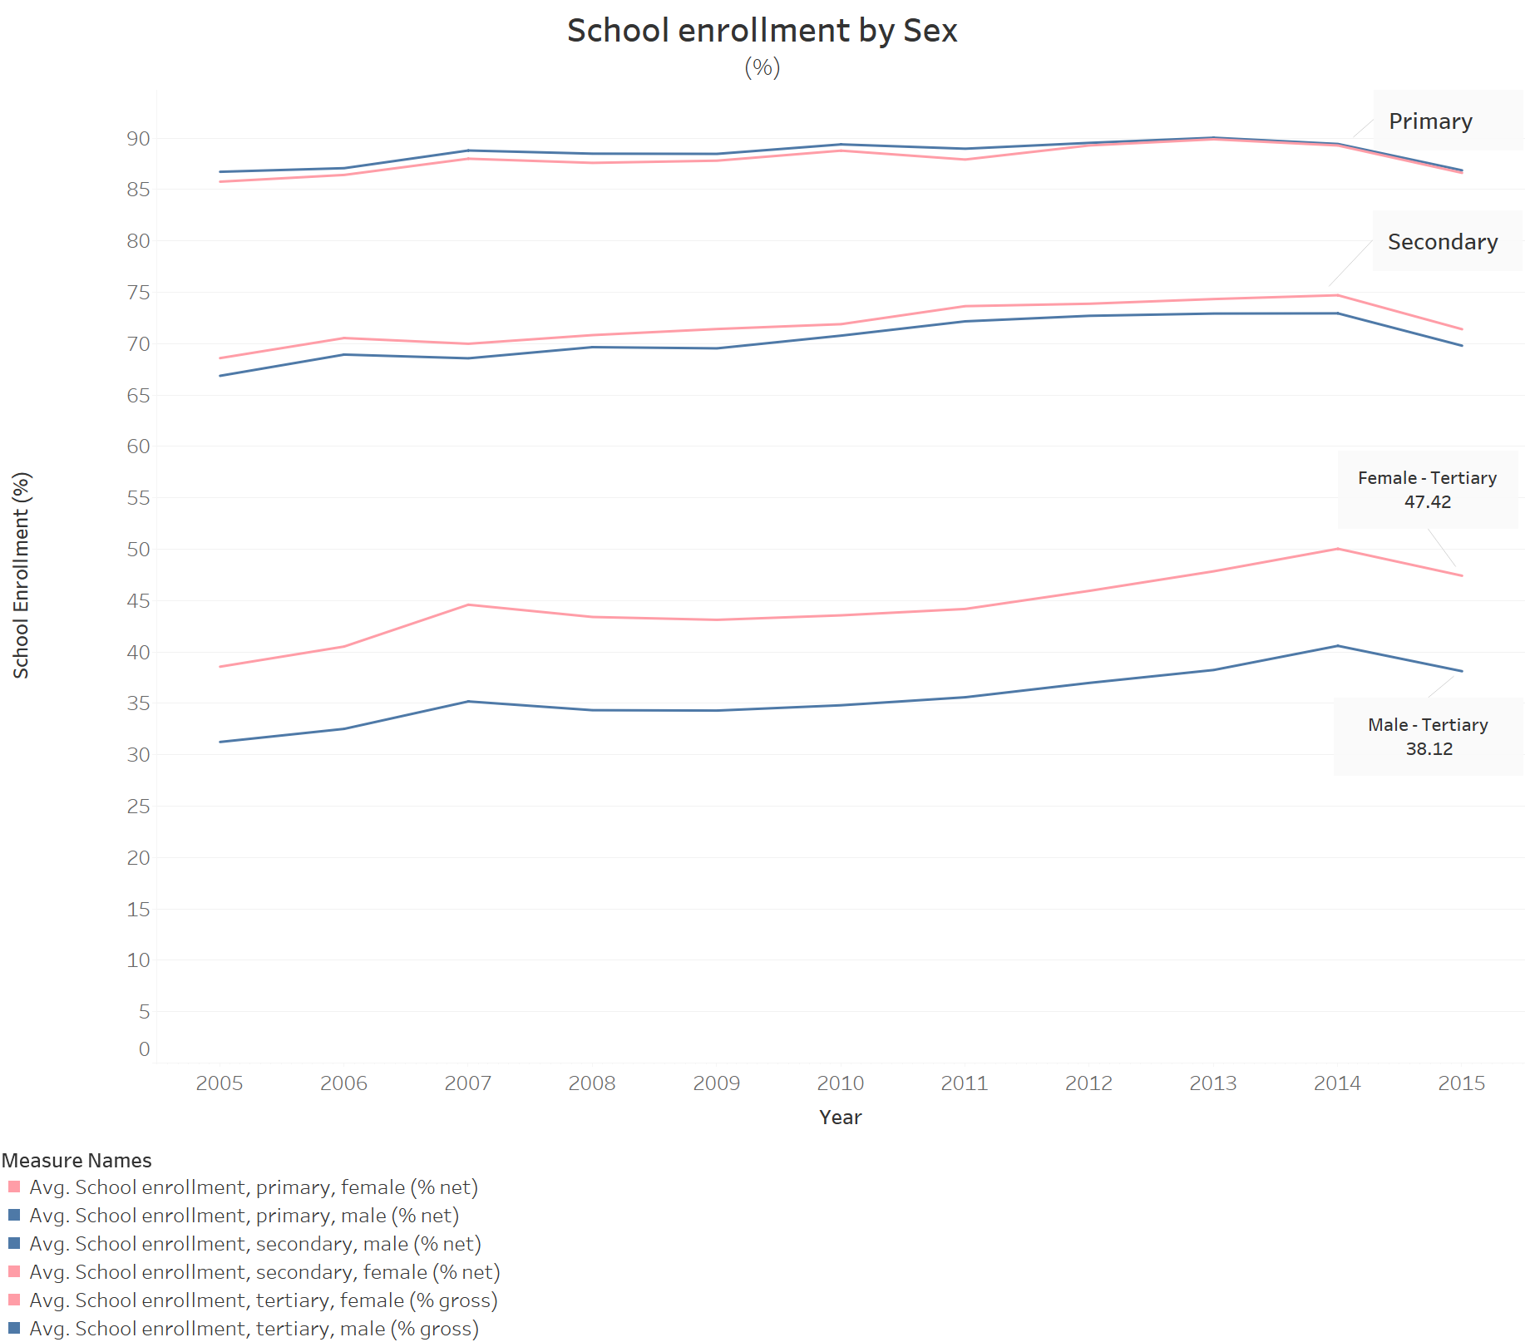

**5.2 Economic participation**

In this index we are going to analyze with three indicators. First of them is labor force % by gender, which can be thought of as the percentage of male and female who contribute to the total labor force population in that country. So as we see in the graph below, the percentage of male labor force is consistently above that of female through 10 years. Although if we look at the difference between the two of them, it decreases gradually (really slow) in the period.

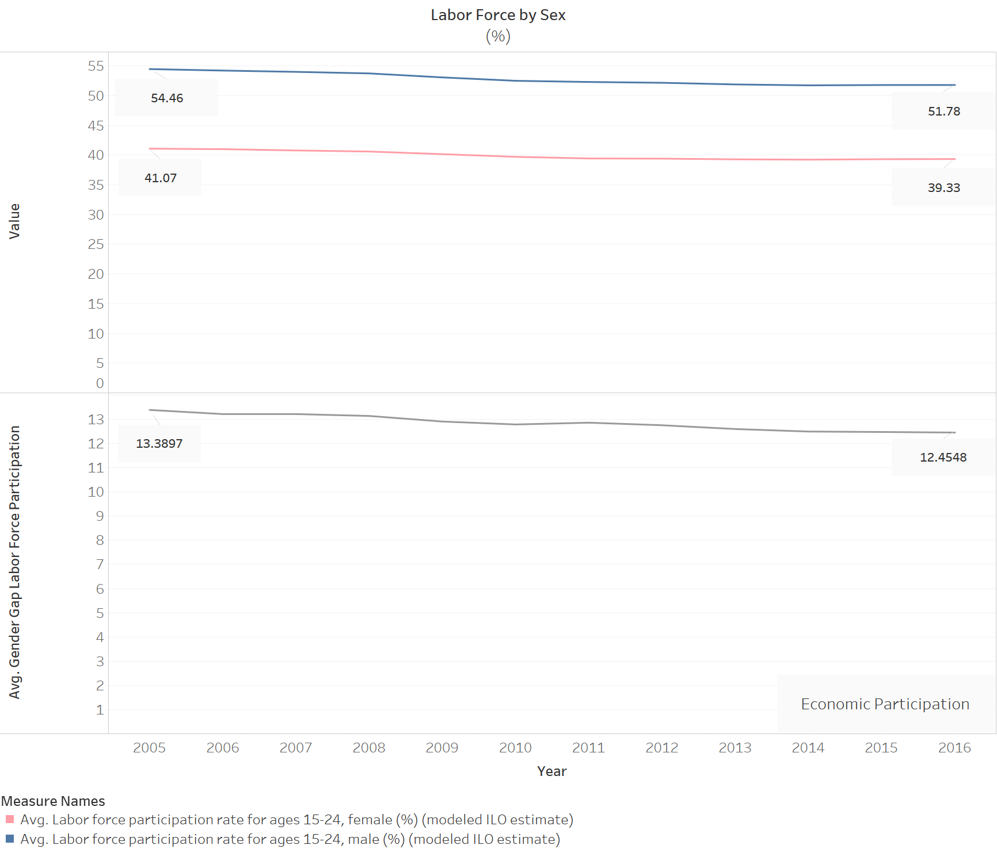

The heat map below shows a comparative study where we can see that in 2005 the countries in pink had more female labor force, whereas in 2015 the countries having more female workforce increased.

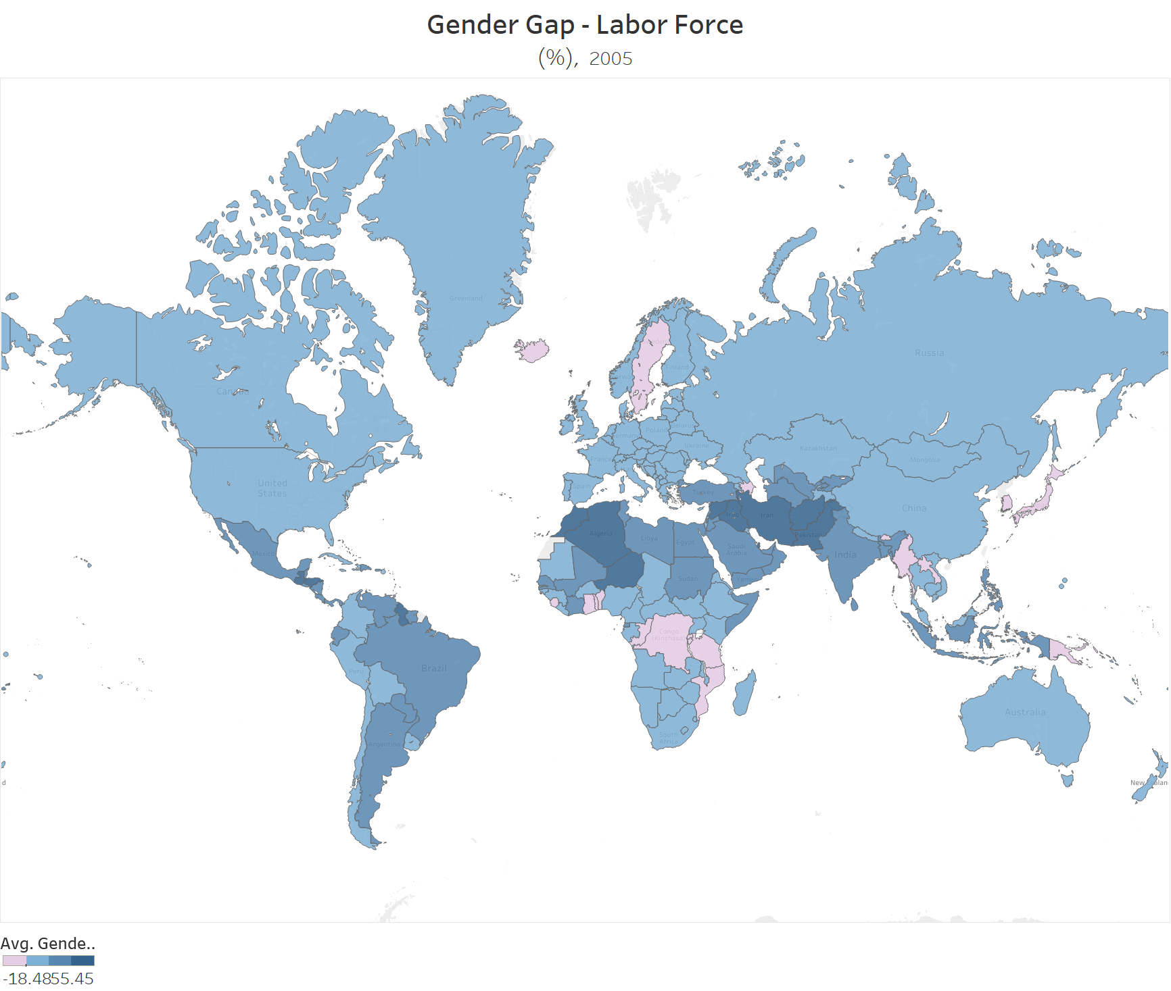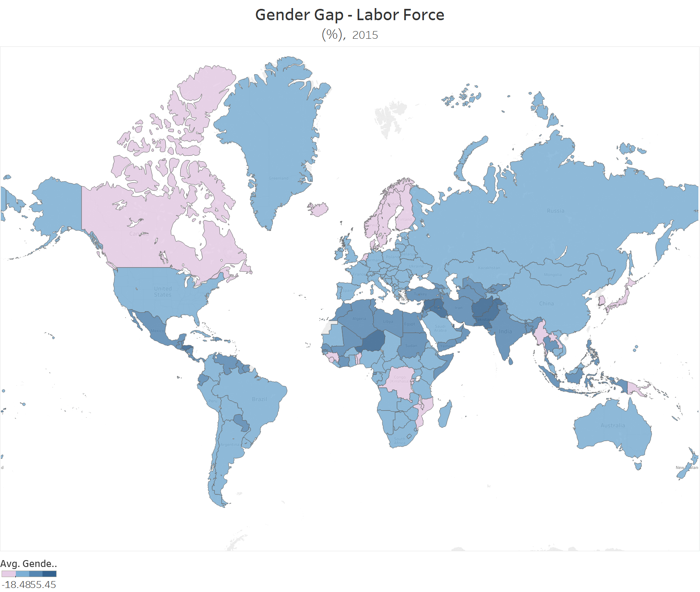

The second indicator of this index would be unemployment %, which should be understood as the % of male or female population without work but available and seeking employment. From the graph below we can infer that the % of unemployment for female has always been higher than the male over past 10 years, also the gap between their percents does not show any significant drop with time.

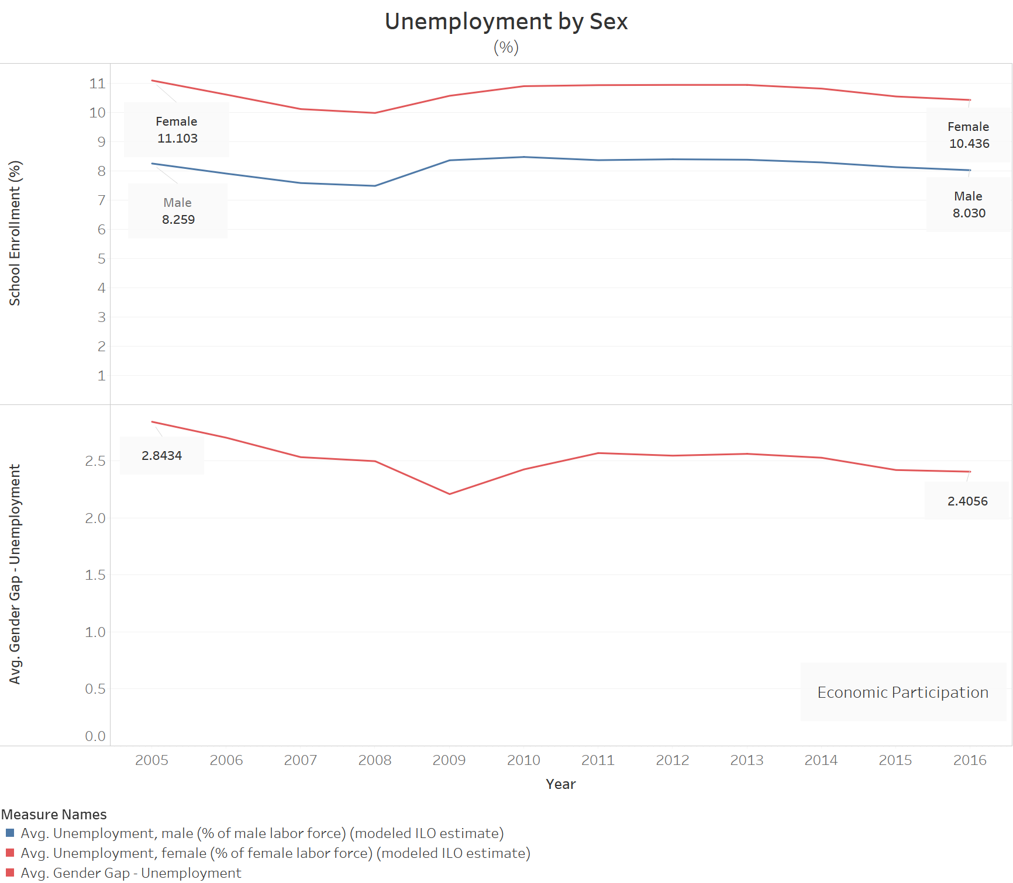

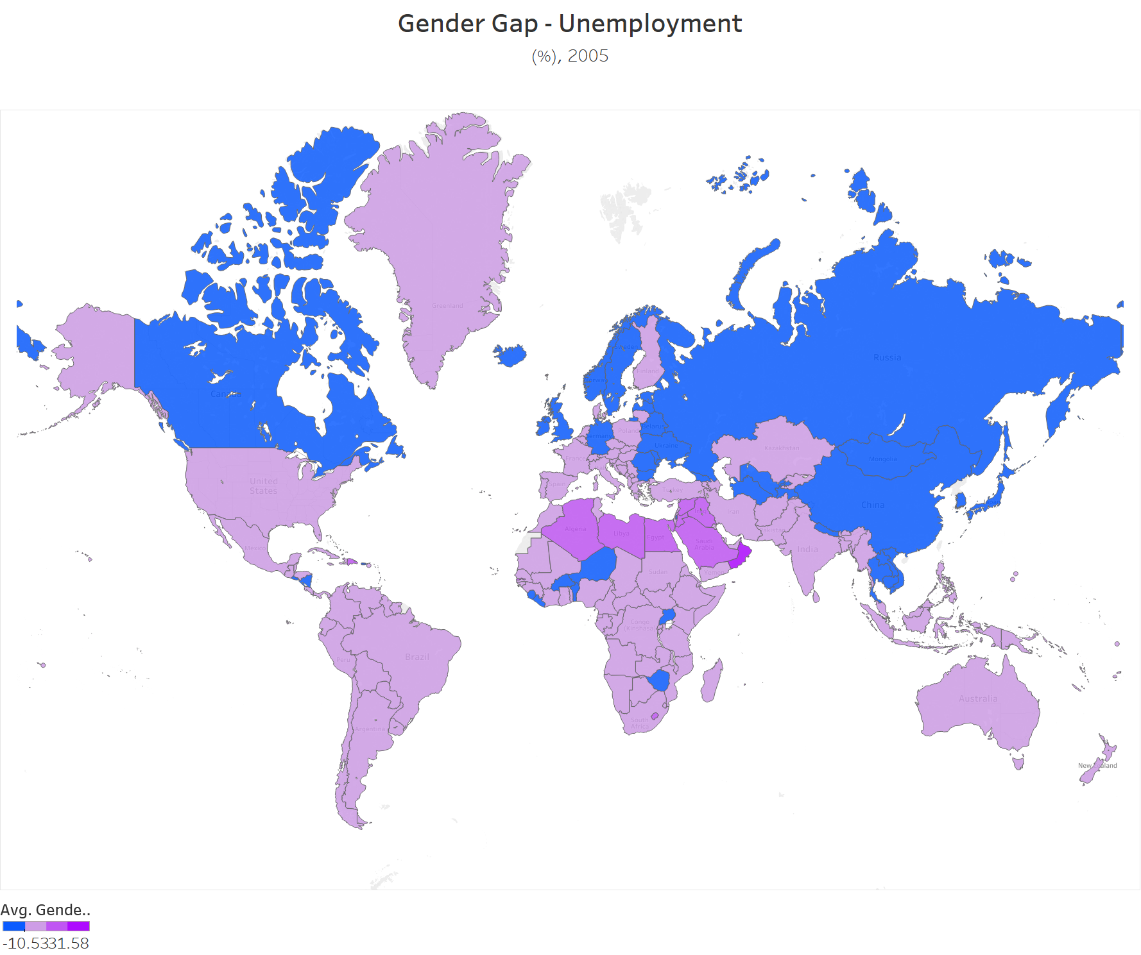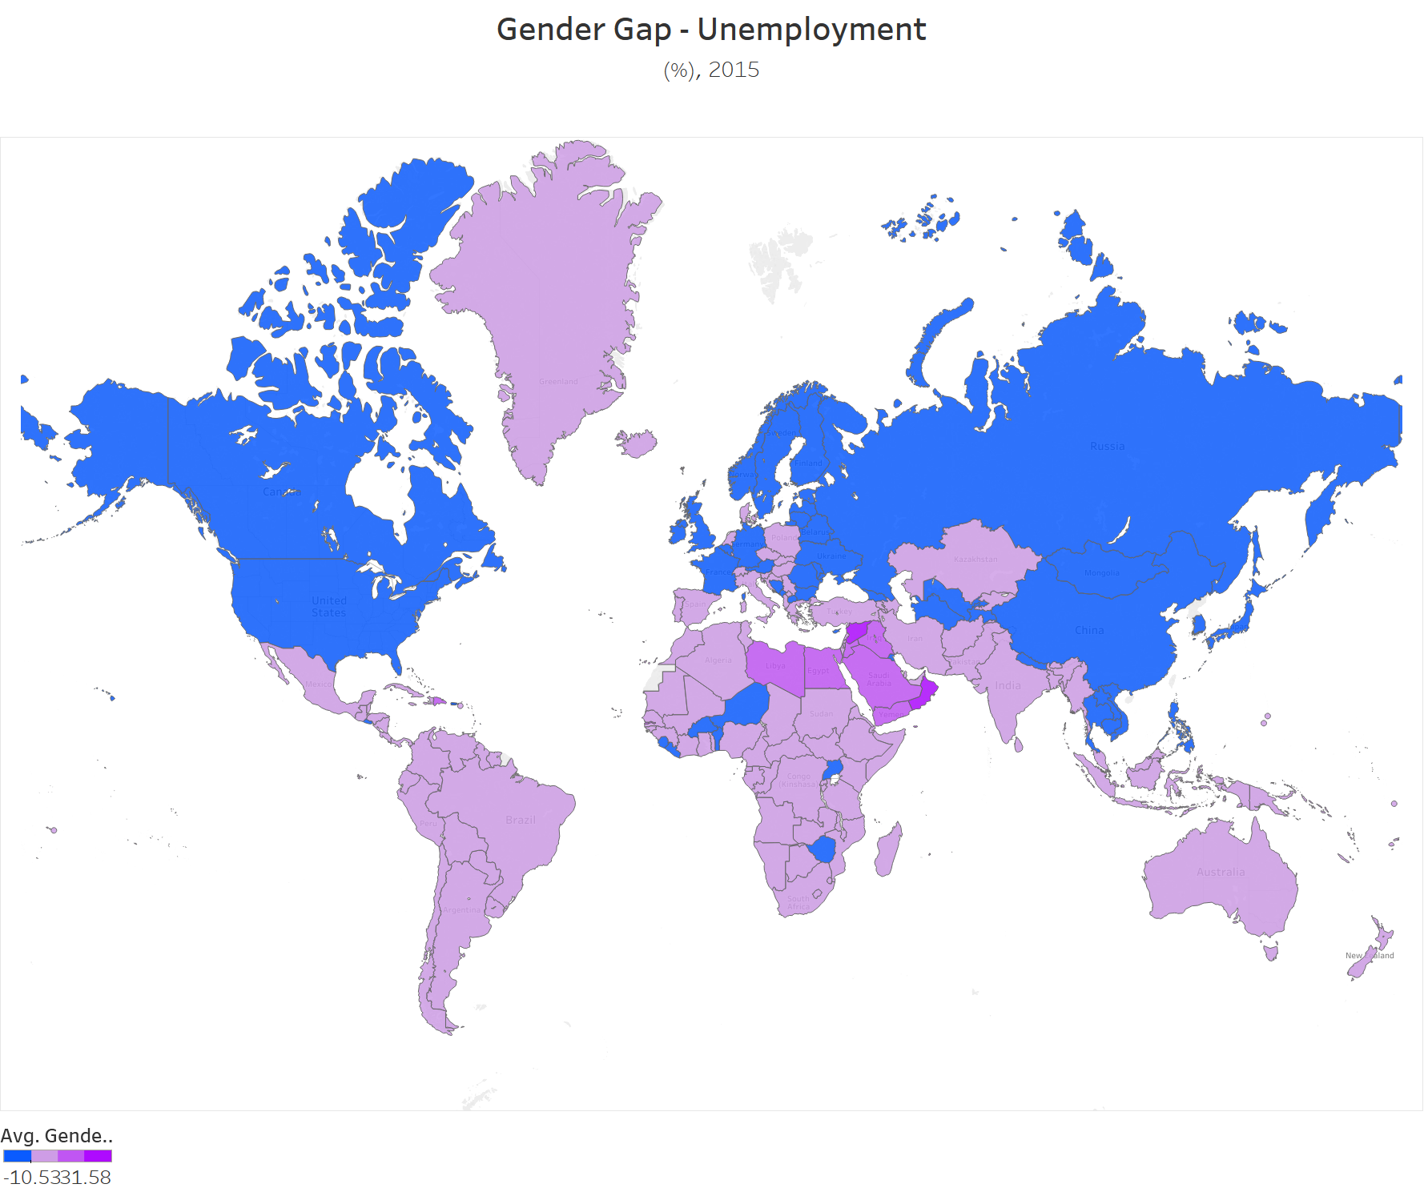

The third estimator for this index we chose to work on would be % of male/female population that are working as the salaried employees. In some countries womens are obligated to work without perceiving any salary. Using this indicator we have seen that in average the gap in favor of females. Now, we are more informed. Also as we do not have the data for majority of the country here, we couldn’t prepare the heat map for this indicator.

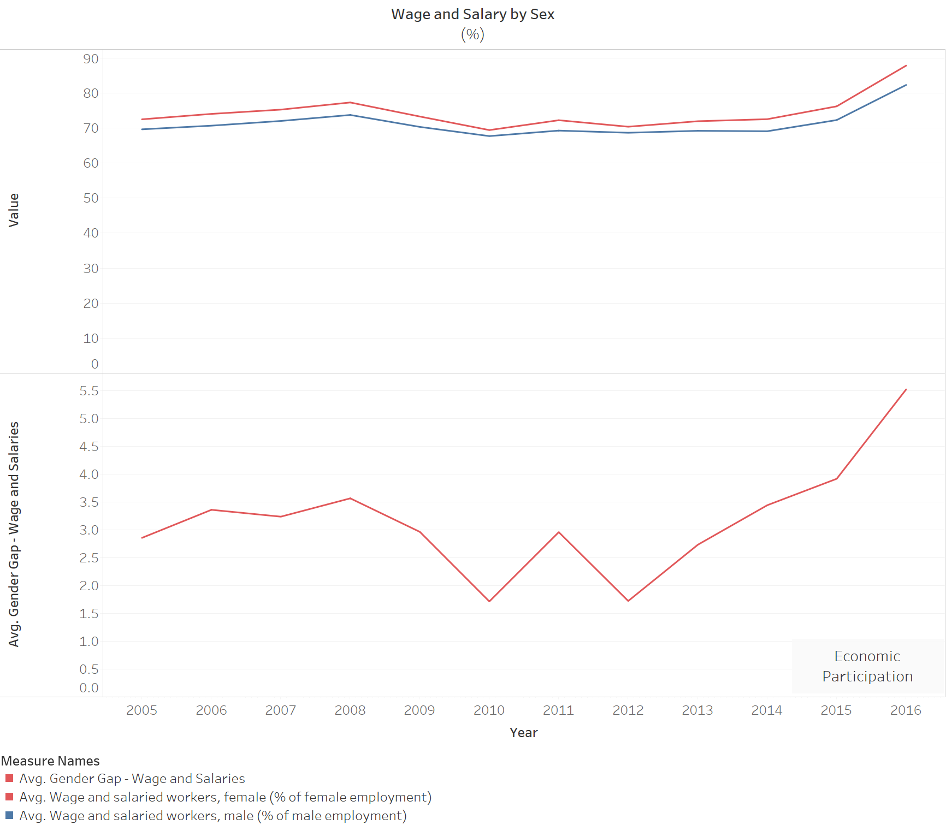

**5.3 Health**

The only estimator for this indicator we chose is the life expectancy at birth % for male & female. Life expectancy at birth indicates the number of years a newborn infant would live if prevailing patterns of mortality at the time of its birth were to stay the same throughout its life. From the heat map below we can infer that there is no change in the life expectancy difference between male and female. And the female seem to outlive male in totality.

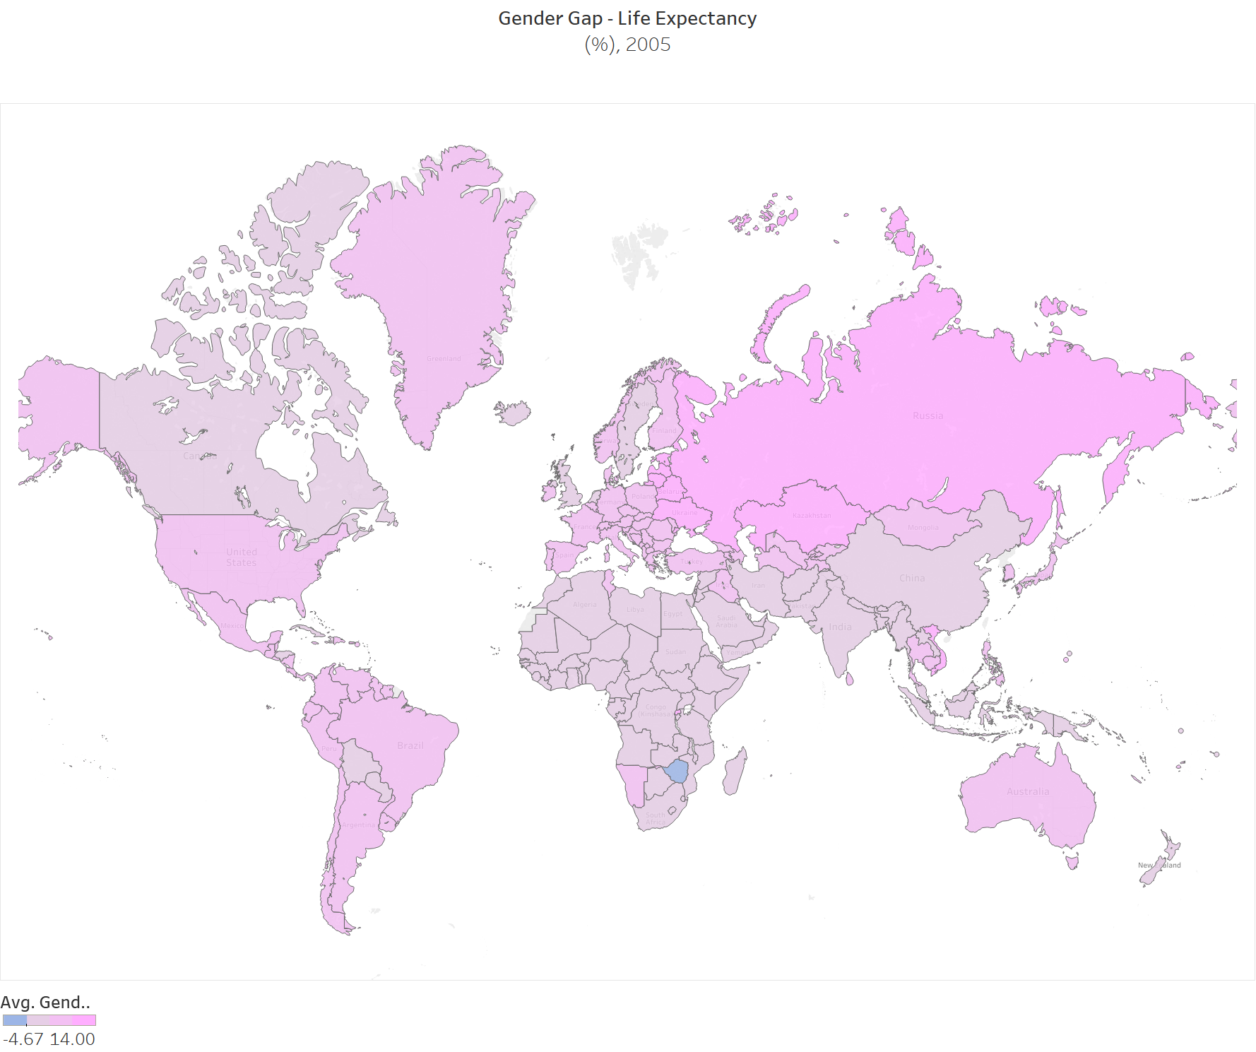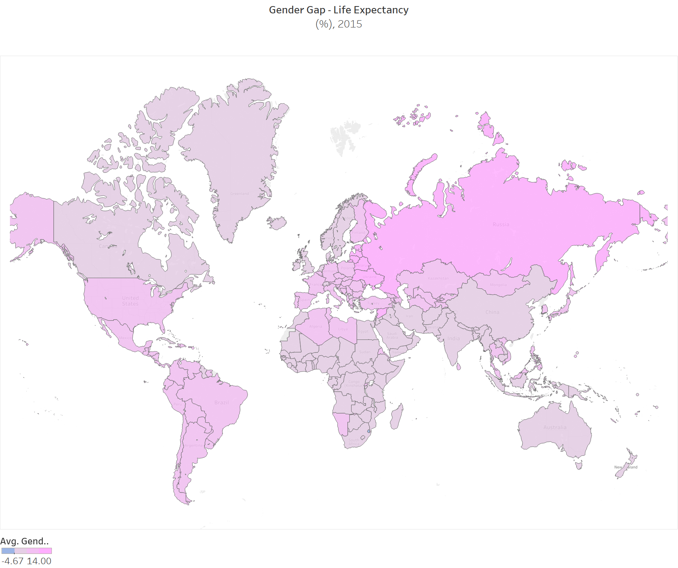

**5.4 Political empowerment**

We are going to measure this index using the estimator “proportion of seats by women in parliaments”, the percentage of parliamentary seats in a single or lower chamber held by women. So what we infer from the heat maps below is that there isn’t noticeably change in female reservation for seats at parliament. It may be because we see the government changing in long period of 4-5 years, and it can be a really slow and time taking process for these kind of amendments in constitution.

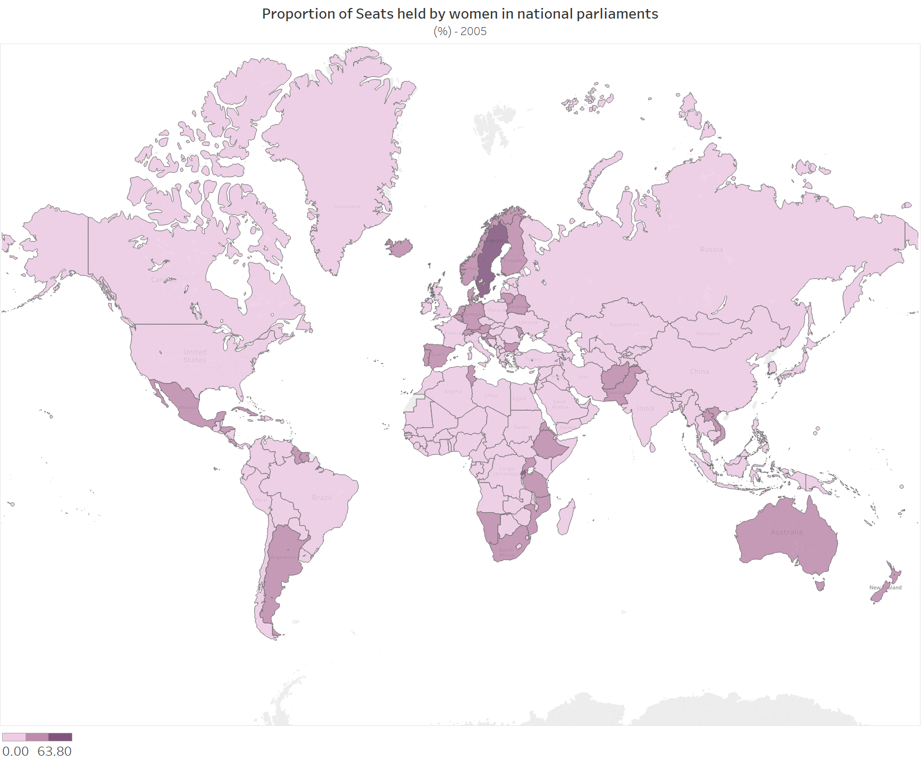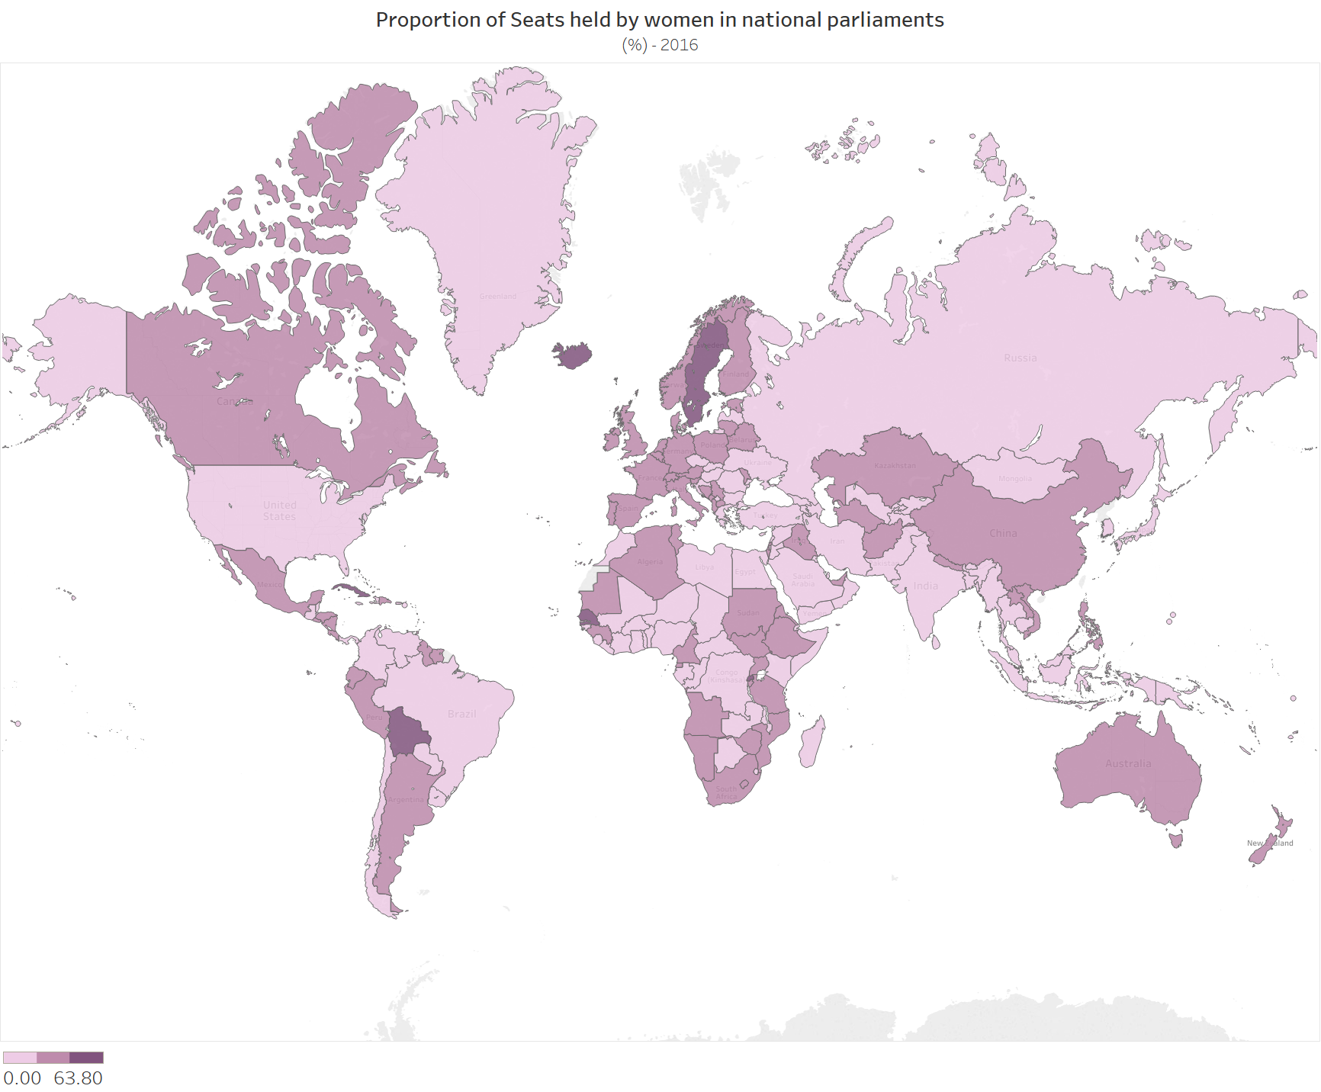

**6. Conclusion**

The main conclusions that we can draw from this study is, we can observe significant reduction in gender gap over 10 years period just for education attainment, whereas the other three indicators, health and political empowerment do not show noticeable improvement.

6.1 Educational attainment

→ Difference in % literacy b/w male & female on an average has come down in past 10 years

→ Difference in percentage literacy has become stagnant since 2009.

→ Africa, Middle east and Southeast Asian regions show biggest gap in gender equality

→ European union, North Asia, some parts of South America show lowest gap in gender equality

The two bar charts below show the top 10 countries in areas where there are biggest literacy gaps either in favor of men or in favor of female. So the government policies in these must be focussed on decreasing the literacy gap as per the requirements in each section.

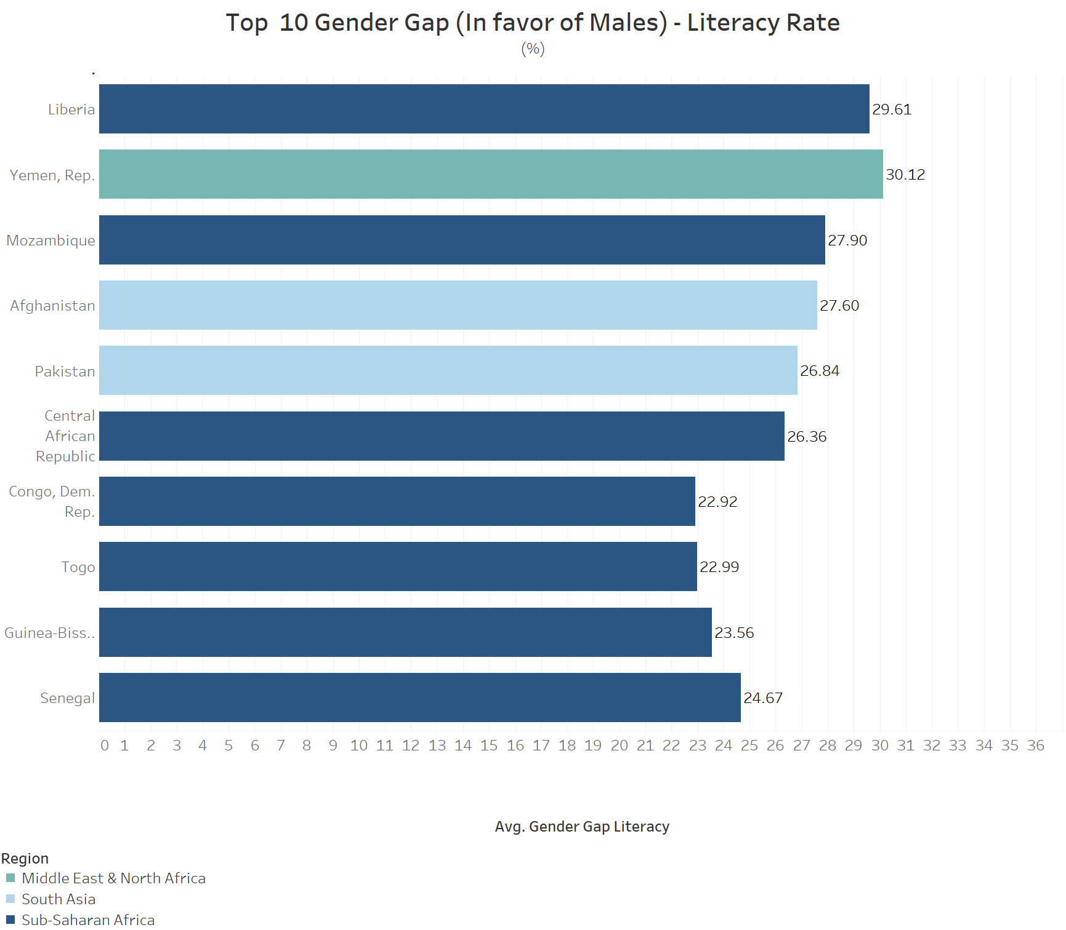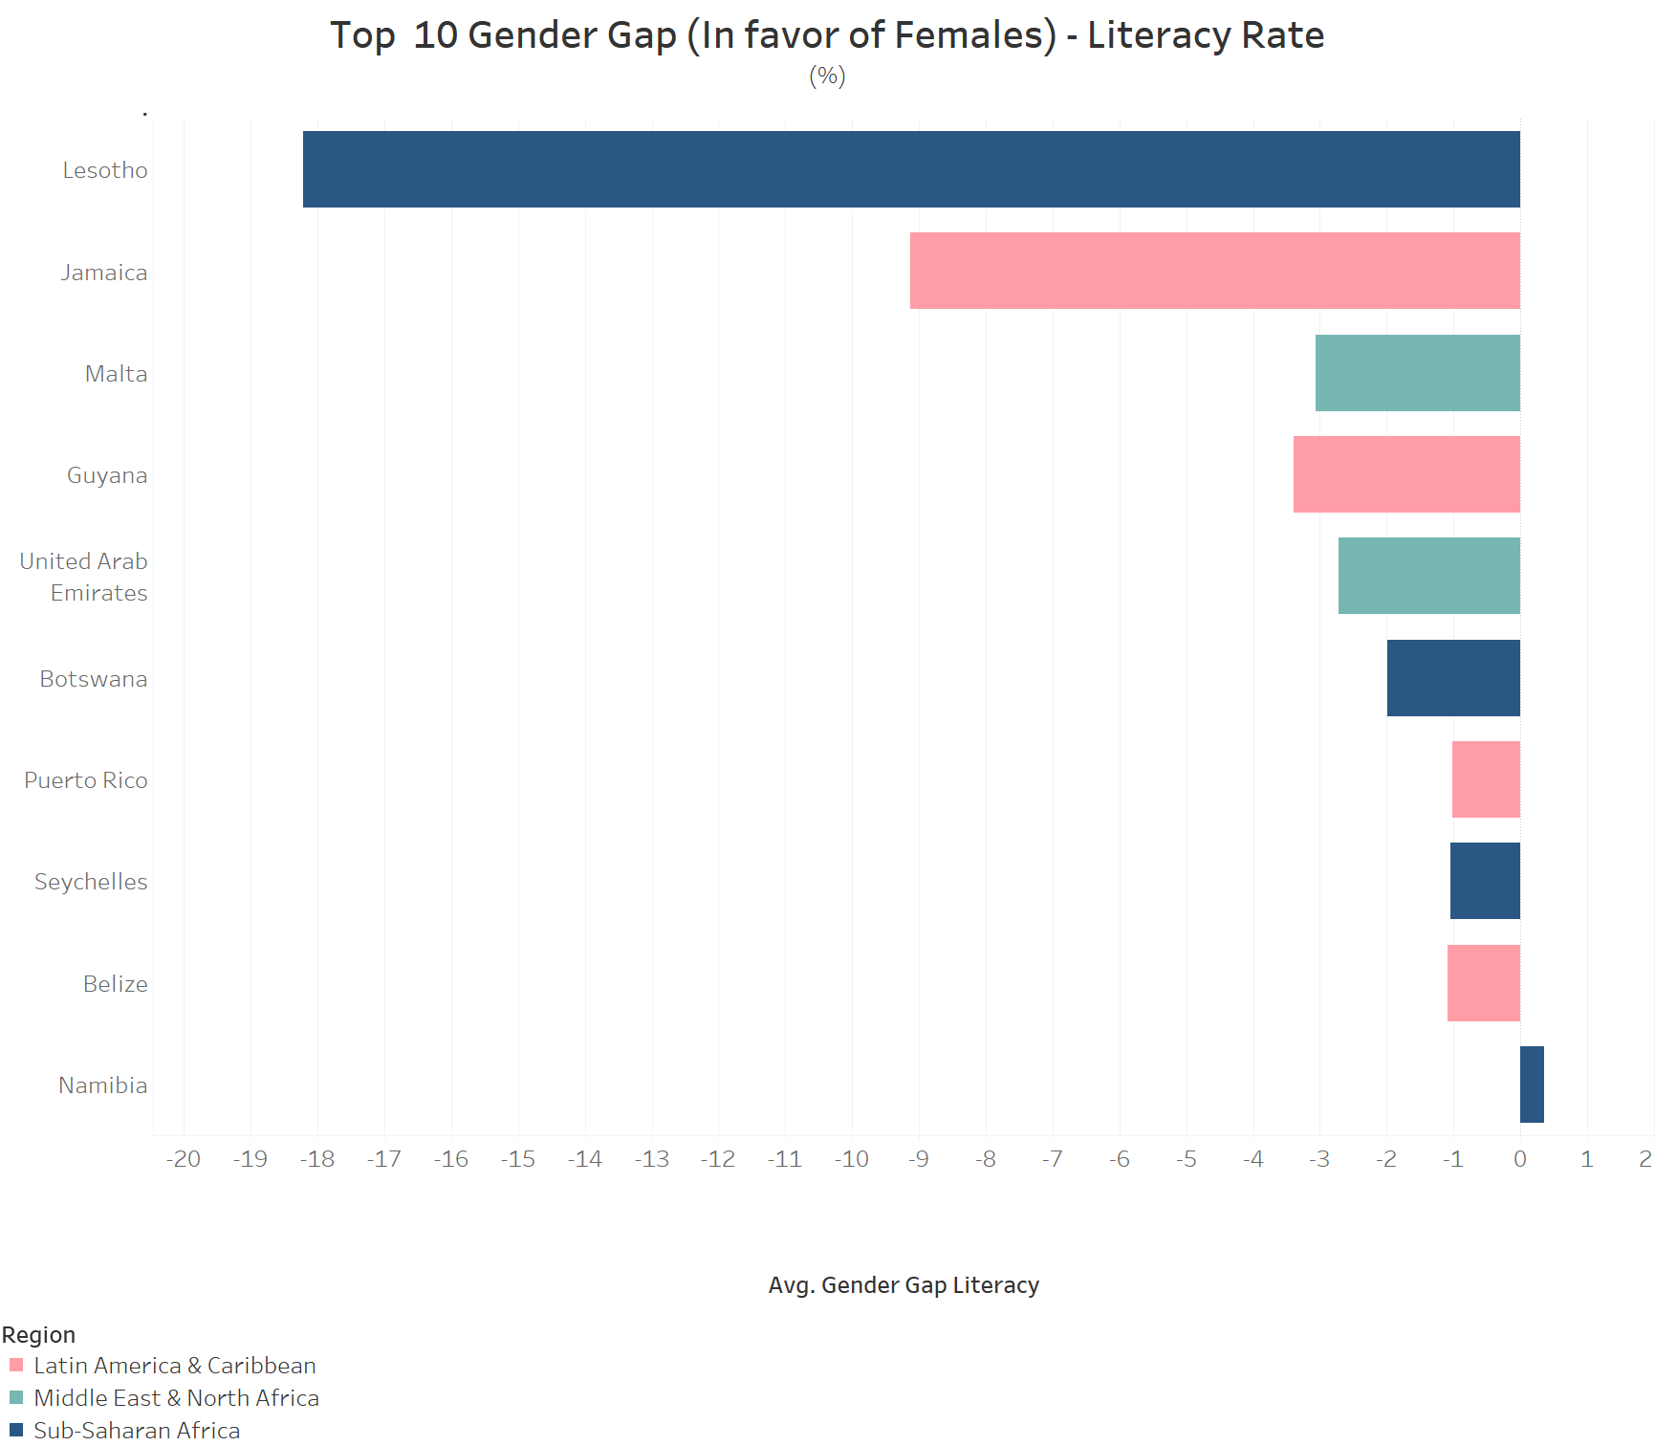

6.2 Economic participation

→ On an average, unemployment rate for women is higher than men.

→ The gap between unemployment of male and female has gone down over the past 10 years.

6.3 Health

→ Life expectancy is higher for women than men.

→ The life expectancy does not significantly change over the period of 10 years.

6.4 Political empowerment

→ We do not see any significant change in this indicator

→ As the elections happen over a period of 4-5 years

→ Bringing new reservations take some significant time.

We believe that to get better analysis we should have consider more indicators and may be a bit longer historical data. Because some trends did not show any change over 10 years of time.

**References**

1. World Bank data on Gender Statistics ([link](http://databank.worldbank.org/data/reports.aspx?source=gender-statistics))
2. World Economic Forum, The Gender Gap Report, 2016
3. McKinsey Global Institute’s work on gender gap report, 2016